## Student Guide for Completing an Exam

1. Do not login to the classroom computer on exam day. Your instructor will provide login instructions.
2. Once logged into a workstation you will see the Exam Instructions window and the Secure Exam window (see below).

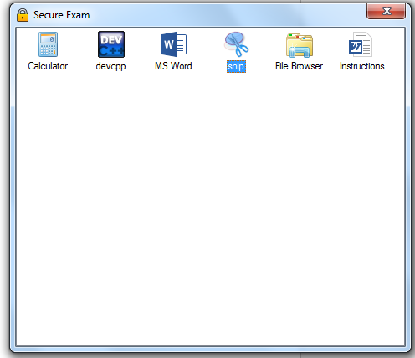

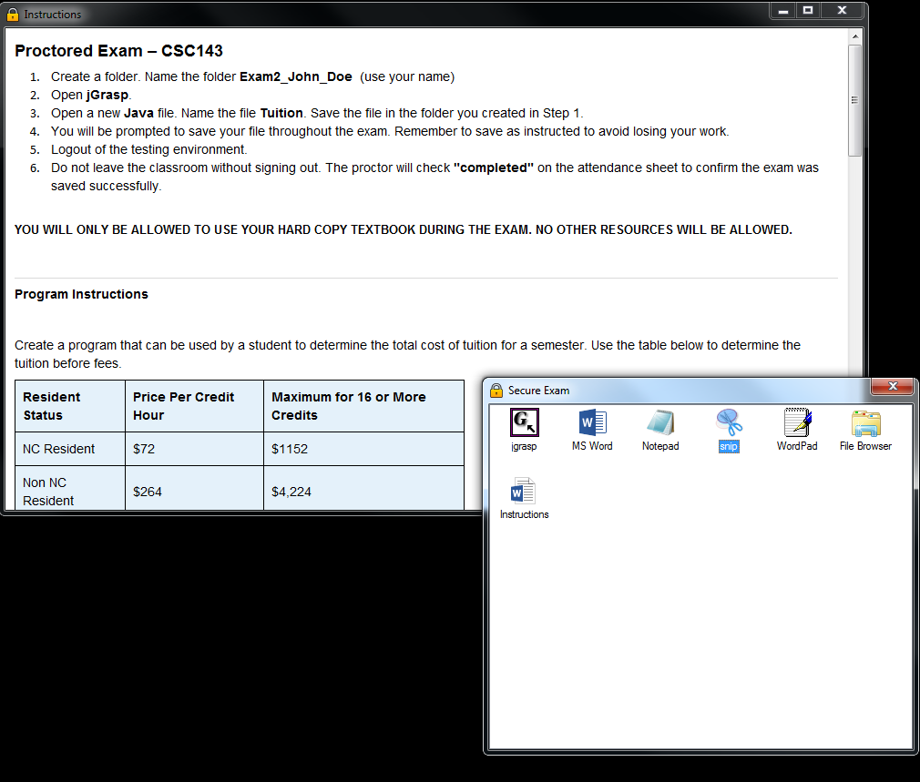

1. The Secure Exam window will have icons for the applications you will use to complete an exam. In the example below **Calculator, DevC++, MSWord, and Snip** are available but your specific list will be different depending on what your instructor is allowing for your exam.



1. If you close the Exam Instructions window, you can reopen the instructions by clicking the Instructions icon in the Secure Exam window.



1. When the exam launches an automatic timer will display in the upper left corner of the computer screen. You can drag the timer to another location on the screen or behind a maximized window such as behind the Exam Instructions window.



1. The Save Reminder window will automatically display at regular intervals designated by the instructor. **Save your exam when you see the Save Reminder alert.** Click the **Dismiss** button to close the reminder.

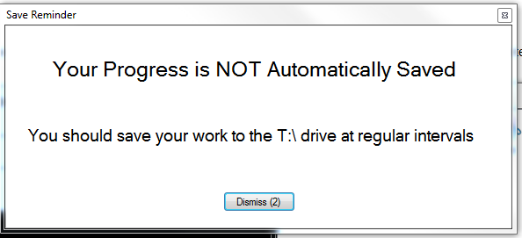

The following steps will demonstrate how to complete a C++ exam.

1. Click the **devcpp** icon in the Secure Exam window.



1. DevC++ will start to install. Click the Next button.

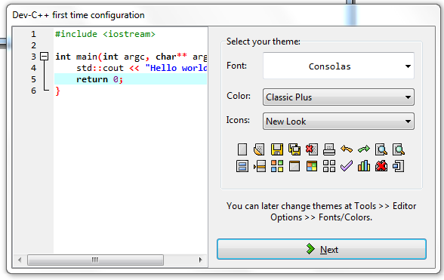

1. After DevC++ installs, a blank DevC++ window will display.

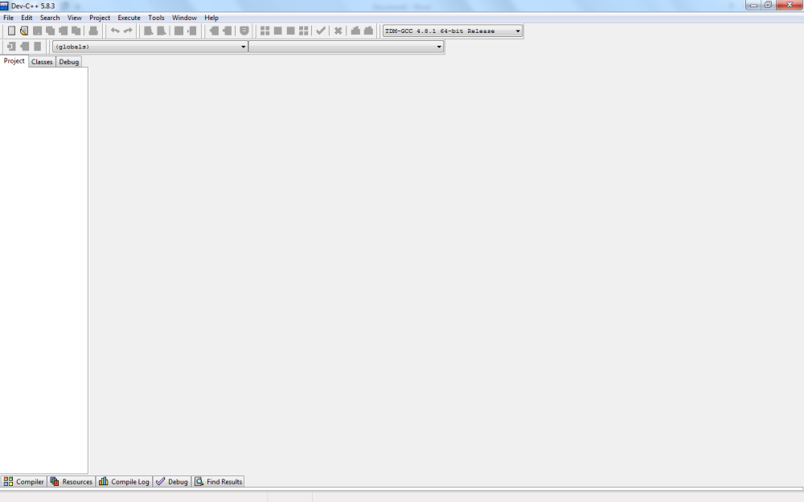

1. Create a new DevC++ source file.

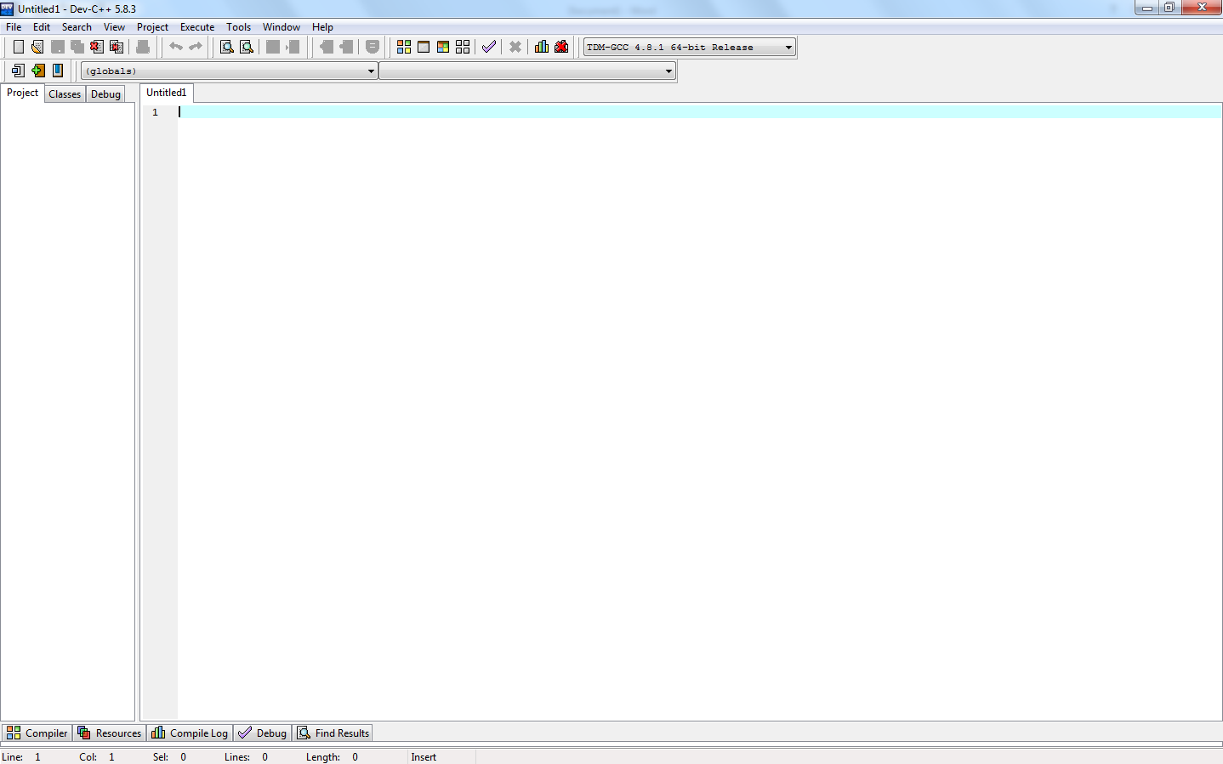

1. Save the blank source file by clicking the **Save** button in the IDE application. The Save As window will display.

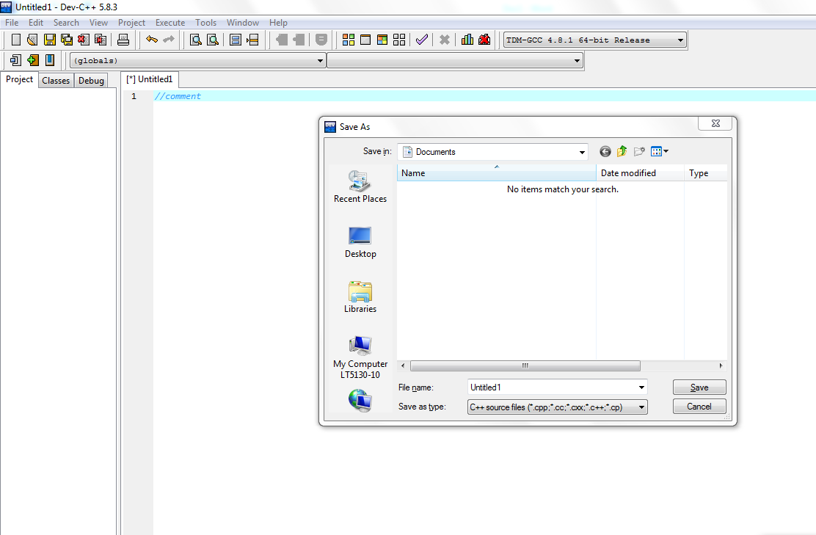

1. Select the **My Computer icon** on the left side of the window.



1. Click the network icon shown in the window.

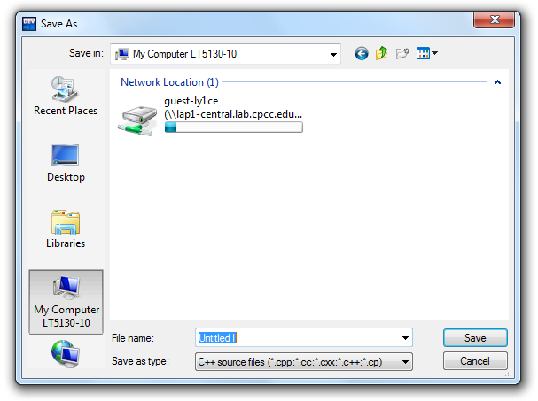

1. Enter the file name **provided by your instructor**. In this example the filename is **Untitled1**. Click the **Save** button.

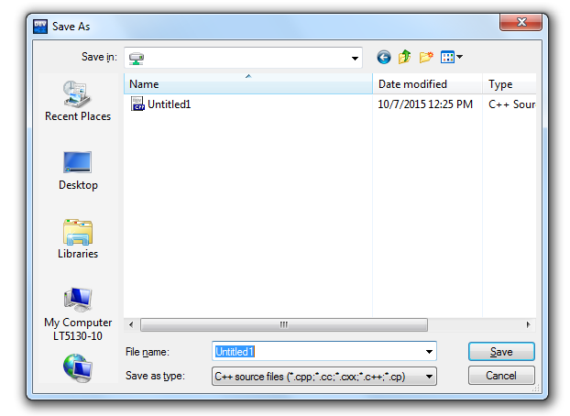

1. After clicking Save, you will return to the saved C++ source file in DevCpp. Complete the exam as instructed. Remember to save the program periodically as you are working (click the **Save** icon on the IDE to save the program.

1. You will not upload your file to Moodle. Your instructor will retrieve your file from the SES environment.
2. Proof your exam **carefully**. Click the **Save** icon in your IDE.
3. Click the “**x**” on the Secure Exam window to close the SES application and the Exam Instructions window.



1. You will know you have logged out successfully when you see the following:

***Press CTRL + ALT + Delete to login***